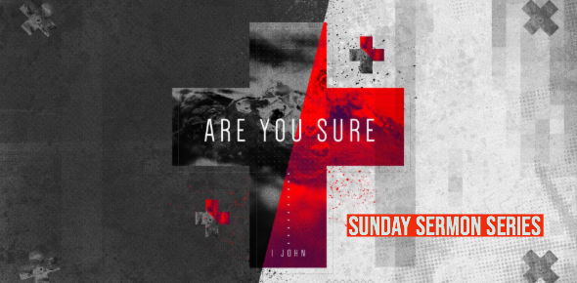

ARE YOU SURE? What is Your Name?
1 John 2:1-6
Sunday, May 26, 2019 - Dr. Johnny Ellison

Scripture provides clear proofs to each Christian to verify if we can truly claim that name.

I. Christian is my name if…

Jesus Forgave Me. 1 John 2:1

Jesus Rescued Me. 1 John 2:2

Jesus Assures Me. 1 John 2:3,5,6

II. Christian is my PSEUDONYM if Jesus
Does Not Control Me. 1 John 2:4

